Series Circuit

Subject:  Related Subjects: | Grade Level(s):4  Length of Lesson: | Type: Inquiry / Design / Project  Keywords:Circuit; series

Lesson Overview
Use this section to describe at a high level what the lesson is. Should be no more than 3-4 lines.

Lesson Focus
Students will build series circuits using LEDs and batteries. Try to have the students record their work in the attached tables.

Lesson Objective(s) | By the end of this lesson, students will…  - Learn the concepts of attraction, repulsion, friction, polarity, and charge.

Lesson Timing

5 minutes | Introduce the Lesson
30 minutes | ...

Materials | - 2 AA battery pack  - AA batteries  - 3 LEDs  - 5 motors  - 4” x 4” piece of foam board  - Electrical tape  - Masking tape  - Scissors  - Wire strippers  - Brass fasteners  - Paper clip
Instructor Prep | - Step 1
Related Resources | - List related lessons/ppts etc available from USC or outside, trusted orgs

Lesson Plan

Introduction
When you continue to add electrical components in series you will eventually have to increase the amount of power in the circuit. This is due to the fact that the electrical components are all sharing the power that runs through the circuit. Thus, if there is not enough power for one electrical component none of them will turn on.
In this lesson we are going to experiment with this concept. We are going to connect LEDs and motors in series and see how many we can connect in series before we have to add more batteries.

Connecting LEDs and Motors in Series
Connecting LEDs in series is different from connecting blue wire lights in series. The way you place the legs matter because one leg is positive and one leg is negative. (Ask the students which is which: long leg – positive, short leg - negative) So, when we connect LEDs in series we have to connect them long leg to short leg. This way we sort of have one big LED, because there is one long leg and one short leg left to connect to the switch or battery.
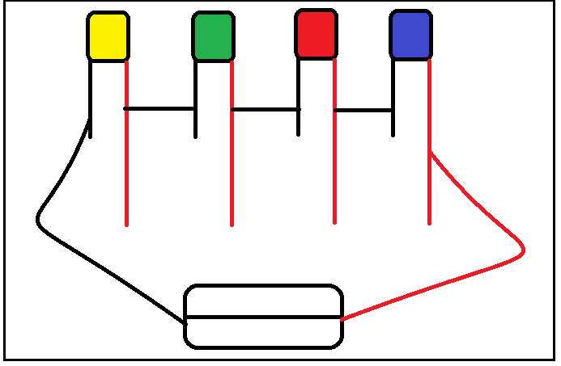
Figure 1. LEDs connected in series

Procedure
The process of connecting motors in series is actually very similar to the process of connecting blue wire lights in series. To connect the motors in series the legs on the motor need to be connected. One leg will go to the positive end of the battery or a switch, the next leg will be connected to the next leg on the second motor, and the last leg on the second motor will be connected to the negative end of the battery.

- Connect two LEDs in series with a switch and 2 AA batteries. (The LEDs in this circuit will not turn on, ask the students to tell you why. They need to figure out that they need more power for the LEDs.)
- Connect two of the 2AA battery packs in series, and use it to power the 2 LEDs that are in series
- Add a third LED to the previous circuit
- Have the students continue to add LEDs in the circuit until there is not enough power
- Repeat steps 1-4 with motors. (Note: two motors can be powered by 2 AA batteries. Have the students add more motors until there is not enough power. And then have them add more power, and see how many motors they can add on until they need more power.)
- Have the students experiment with series circuits of their own design using motors and LEDs
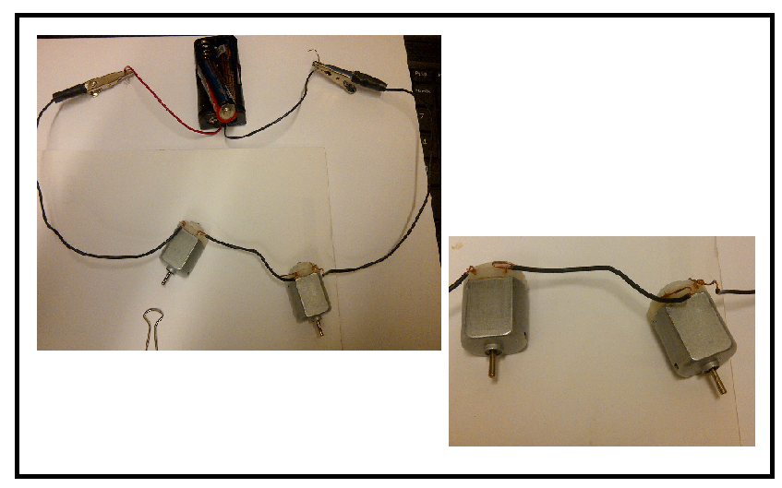
Figure 2. Motors connected in series

Wrap-up
End the lesson with some final discussions about what students designed/discovered. Connect their activity back to the focus question/problem, real world examples, and STEM careers.

Also include notes about any special cleanup considerations

Lesson Background for Teachers

Suggested Real-World STEM Connections
- List possible related Role Models in STEM (with details and links to more reading). Give suggestions for examples of scientists/engineers who are from underrepresented groups in STEM in related careers.
- List related real-world engineering problems and examples

Lesson Variations and Options
Include descriptions of alternative methods or ways to present things.

Explanation
Describe the background concepts and explanations behind the lesson. This can be more in depth than a teacher/instructor would actually share with students.

Key Concepts and Vocabulary
- Word 1: Grade Appropriate Definition
- Word 2: Grade Appropriate Definition

Safety Notes
- Safety instruction

